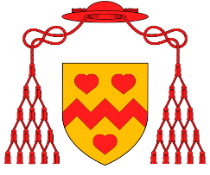
Welcome to our HRSE Newsletter: ‘Heart Speaks to Heart’
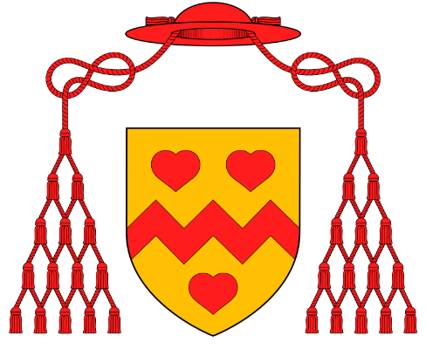
St John Henry Newman
Catholic School
St John Henry Newman
Catholic School
“Parents are the first educators of their children. It is their right and responsibility to inform and educate their children in matter relating to human growth and development”. Our mission at St John Henry Newman Catholic School is to educate our students in the wholeness of mind, body and spirit through the teachings of Jesus Christ. We aim to work with parents, carers and the wider Catholic community to provide students with a comprehensive education that prepares them for life. HRSE is an important part of this.
Parents have the right to request that their child be withdrawn from some or all of sex education delivered as part of statutory HRSE up to three terms before the child turns 16. None of the topics this half term are deemed to fall under the category of ‘sex education’. However, if you have any concerns or would simply like to discuss the HRSE provision with a member of staff, please contact Miss Lowrey, Assistant Headteacher and Lead for HRSE: emilylowrey@newman.cumbria.sch.uk.

Year​ | Topic outline for this half term​ | How can you support your child with this?​
7 | Topic: Tobacco and vaping  - Why do some people choose to smoke?  - Dangers of smoking  - Laws surrounding tobacco  - Vaping  - Anti-smoking campaigns | - Whilst we do not aim to be judgemental of people’s lifestyle choices, it is important that as parents and a school working together we stress to students that smoking and vaping are a serious health hazard and should be discouraged.  - If you smoke, perhaps you could discuss with your child the reasons why you chose to do so and why quitting is not as easy as it may sound to a young mind.  - If you do not smoke, you could ask your child what they learned in HRSE this week and use this as a basis for discussion.  - Be alert for signs of your child smoking or vaping.
8 | Topic: Democracy  - How does the UK democracy work?  - General and local elections  - Party politics – what do the major parties profess to stand for?  - Why is democracy important?  - Why is it important to use your right to vote? | - We aim to present this in a politically impartial way and we recommend that parents discuss this with their children in as impartial a way as possible.  - Read the news with your child and discuss politics openly.  - If there is an election, discuss the process with your child. Perhaps take them to the polling station or show them what a postal vote looks like.
9 | Finance and gambling  - Finance, budgeting, bills, taxes  - What is gambling?  - Gambling laws  - Addiction  - Impact of gambling | - Talk about finance and gambling with your child. Could you let them help with household finances? Could you give them a fictional (or real) budget to allocate to certain things?  - If they get pocket money, discuss the responsible use of money and how this might feed into full time or part time jobs that they may get in the future.  - Discuss gambling and the concept of moderation.
10 | Topic: Abuse of illegal substances  - Types of drugs  - Effects of illegal drugs  - “Legal highs”  - Abuse of prescription drugs  - County Lines | - Again, we do not aim to be judgemental of anyone’s choices but it is important that we all stress the illegality of drug use, including abuse of prescription drugs.  - Ask your child what they have learned and use this as a basis for discussion.  - Ensure that students are aware of the risks. If you have prescribed or over-the-counter medication in the house, ensure your child understands the difference between genuine medical use of such drugs and illegal, addictive, abusive use of such drugs.  - Be alert for signs of drug use or involvement in drug trafficking from your child.
11 | Year 11 have now completed the HRSE course and this lesson will return to the RE department in order to allow more targeted revision for their GCSE.

Where can you or your child get additional support with issues covered this term?​

- Our safeguarding lead, Mrs Mooney
- Students can access support in schools through their tutors, head of year, or any member of our pastoral team
- Kooth – a counselling service accessible through the school website
- Your GP for issues surrounding health​
- Your local parish priest​
- Call the police immediately if you believe you are dealing with issues where a crime may have been committed.
- www.NHS.uk
- www.taize.fr/en_rubrique2603
- www.addictionhelper.com
- www.bacp.co.uk
- www.childline.org.uk or 0800 1111
- www.addictionhelper.com
- http://www.gamblersanonymous.org.uk
- https://www.mentalhealthandmoneyadvice.org
- http://www.nationaldebtline.org
- https://www.nhs.uk/conditions/stress-anxiety-depression/coping-with-financial-worries/
- http://www.papyrus-uk.org
- http://www.uk-sobs.org.uk
- https://www.prevent-suicide.org.uk/stay_alive_suicide_prevention_mobile_phone_application.html
- https://www.riftrefunds.co.uk/tax-rebates/uk-tax-refund-advice/tax-debt-and-mental-health/#takingsteps
- http://www.youngminds.org.uk
- http://www.ukna.org Phone: 0300 999 1212
- http://www.talktofrank.com Phone: 0800 776600 Text: 82111

